Daniel Wright

EE 310

Section 6

Experiment 8

Rocket Probe Lab

**Introduction:**

The purpose of this lab is to use op amps to create a larger systemic circuit. We can design each stage by using an op amp and then connect everything to create the final circuit. In this lab we will use the op amp as a linear device, as an amplifier, and as a non-linear device for the comparator. This specific lab deals with creating a device that might be on a rocket. This device will have to collect charge, convert it to voltage, remove common mode signal, and also integrate with PCM. At the end a comparator is used to tell polarity of the bias signal.

Diagram of Probe Signal Conditioning and Interfacing Circuits

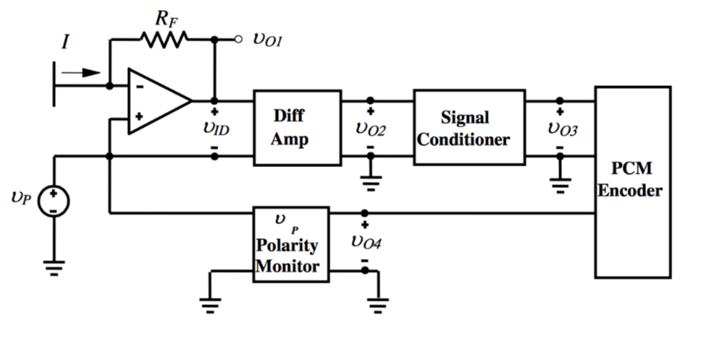

**Block 1: Transresistance amplifier (converts voltage)**

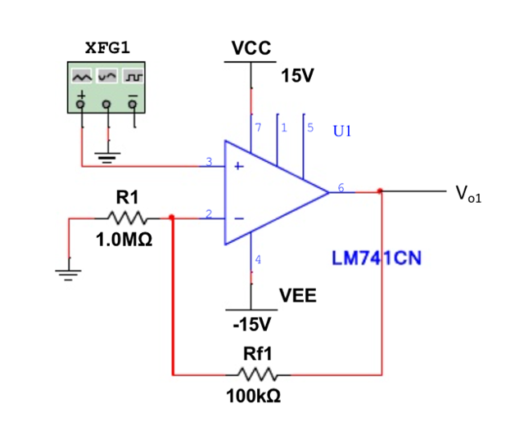

This part of the circuit essentially converts input current into a voltage source.

R1 = 1 M ohm and Rf1 = 100k ohms

Vp/R1 + Vp-Vo1/Rf1 = 0

Vo1 = Vp * (1+Rf1/R1) = 20Vpp * (1+100k/1M) = +- 11 V = 22 Vpp

I = Vo1/(R1+Rf1) = +-11 V / (1 M + 100k) = +-9.09 uA

**Block 2: Differential Amplifier (removes bias voltage)**

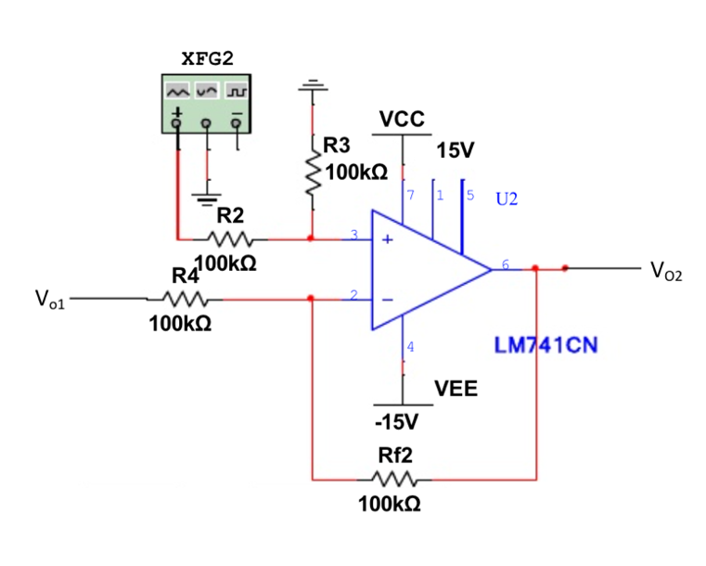

This part of the circuit removes the bias voltage from the output. We got R2 = 100k and R3 = 100k and R4 = 100k and Rf2 = 100k. All in ohms as they are resistances.

V+ = (R3/(R2+R3)) * Vp and V- V+

V—Vo1/R3 + V—Vo2/Rf2 = 0

Vo2 = (Rf2/R3 +1)*(R3/R2 +R3)Vp-(Rf2/R4)*Vo1 = (100k/100k+1)*(100k/100k+100k)*Vp-(100k/100k)*vo1pb ++

Vo2=Vp-Vo1 = 2Vpp

**Block 3: Signal Conditioner**

This part of the circuit makes sure the output voltage is in the range 0 to 5 V.

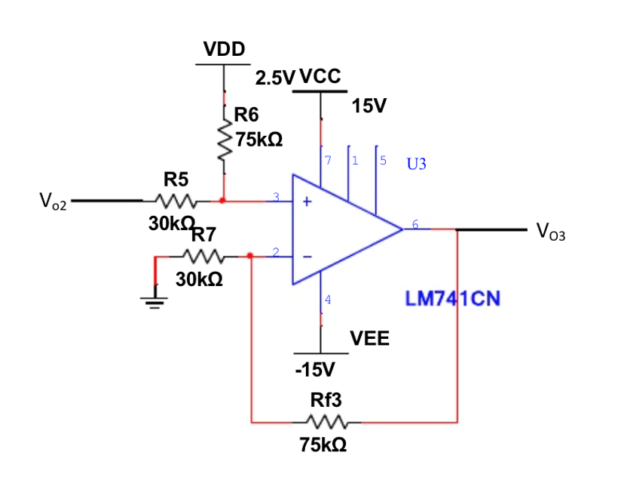

This circuit makes sure Vo be in the range of 0 to 5 V. The resistor values for the comparotor are R5=30k, R6=75k, R7=30k, and Rf3 = 75k all in ohms.

V+ = (R6/ R5 + R6) * Vo2 + (R5/R5 + R6) * VDD and V-=V+

V-/ R7 + V- - Vo3/Rf3 =0

Vo3 = (Rf3 + R7/R7) * (R6/R5 + R6) * Vo2 + (Rf3 + R7/R7) * ( R5/R5 + R6)*VDD

Rf3/R7 = R6/R5 = 2.5 From here, we get resistor values from above.

Vo3 = 2.5 Vo2 + 2.5 V

**Block 4: Polarity Monitor Subsystem**

This part of the circuit establishes polarity. It uses voltage division and comparator to test if the voltages are at a certain threshold.

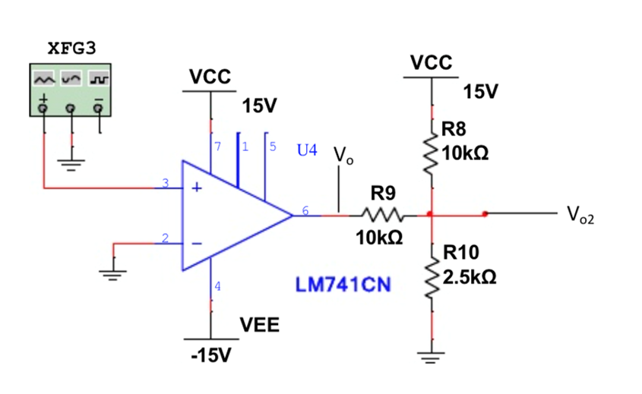

Vo2-Vo/R9 + Vo2-15V/R8 + Vo2/R10 = 0

Vo2/R9 – Vo/R9 + Vo2/R8 – 15/R8 +Vo2/R10 =

Vo2 = (15/R8 + Vo/R9) * (R9 + R8/1 + R10/1)

When Vo = 15 V Vo2 = 5V

R9=4R10 then R9=10k ohms and R10 = 2.5k ohms

**Data:**

Block 1:

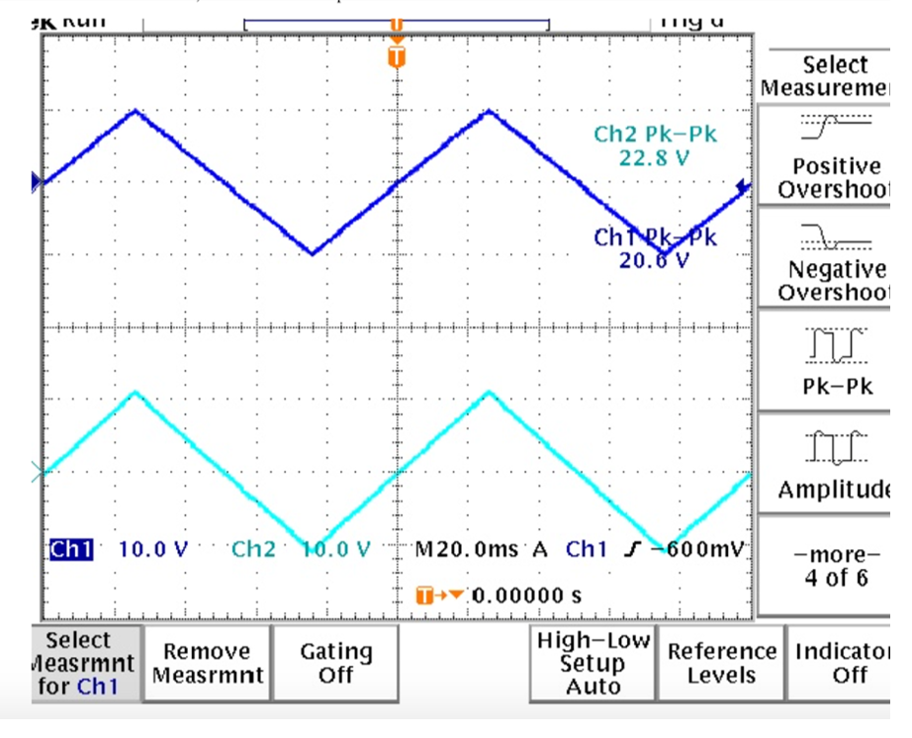

Block 2:

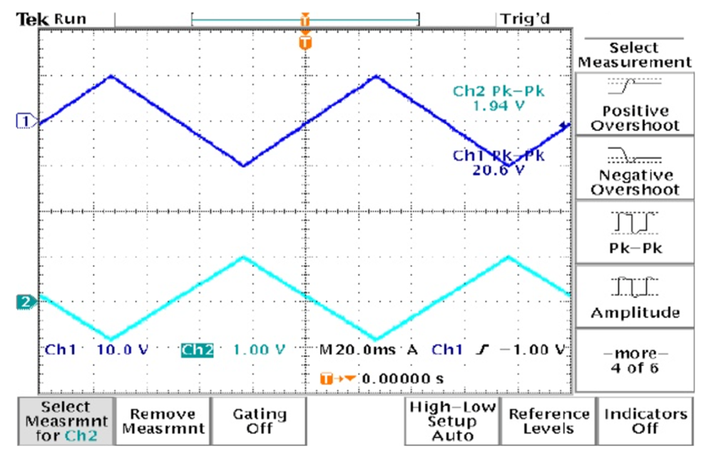

Block 3:

l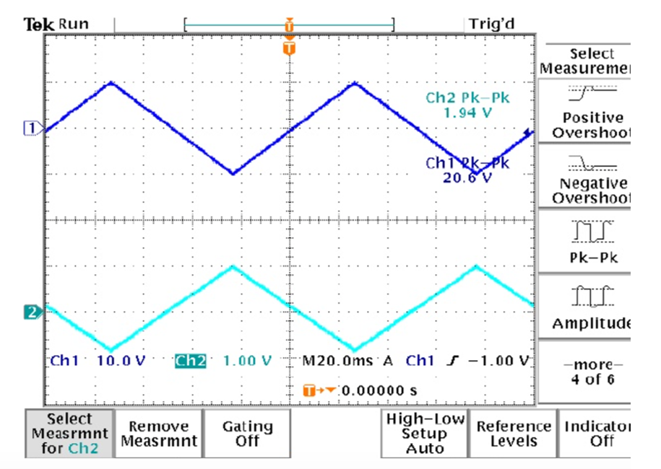

Block 4:

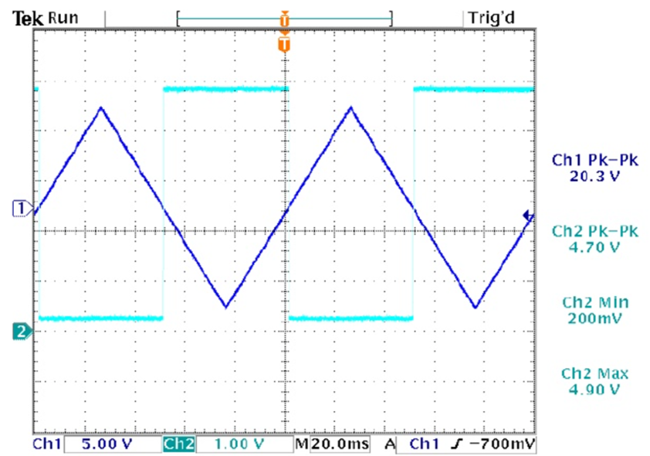

**Discussion:**

Simulation results:

Block 1:

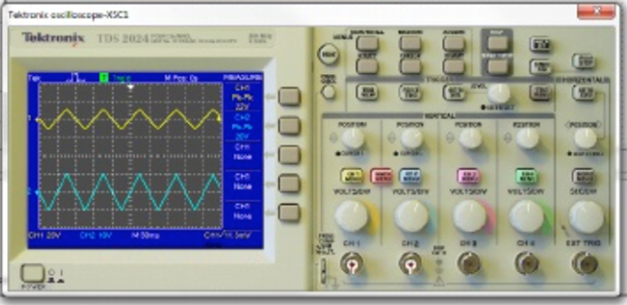

Block 2:

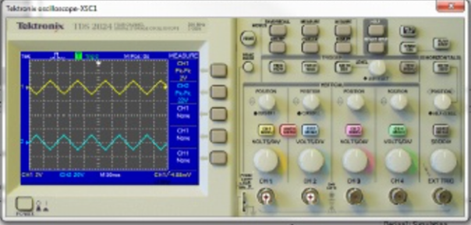

Block 3:

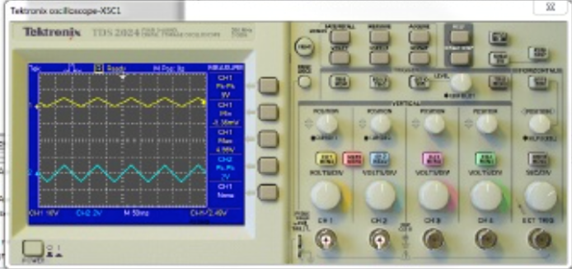

Block 4:

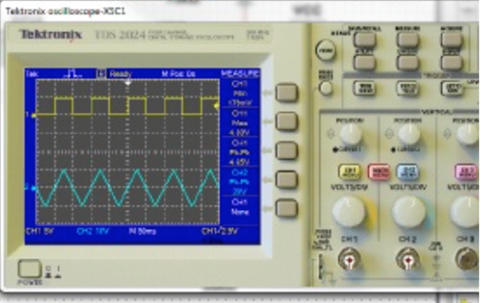

Output:

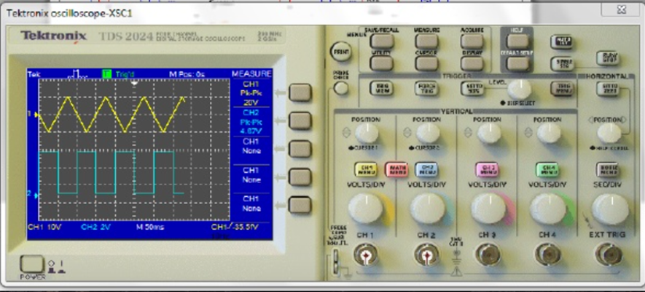

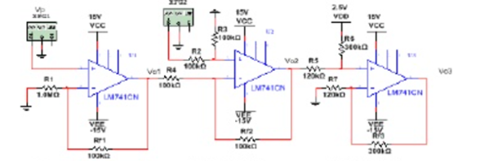

**Results:**

Our results seemed to match the simulation

22 Vpp = 22.8 Vpp

2 Vpp = 1.94 Vpp

Vo3 and Vo4 were both in the range of 0 to 5V which is what was intended.

We had slight percent errors but overall were very good.

%error = Abs((theoretical-experimental)/theoretical)

Block 1 = 3.63 %

Block 2 = 3%

Block 3 = 6%

Block 4 = 6%0

These errors are very low and were probably caused by slight differences in the resistor values, as they are not 100% accurate.

**Summary and Conclusion:**

This lab was a success. We designed all the parts independently to perform a certain function, then connected them all together to form the larger system. We tested in Multisim, and everything seemed to add up with the predicted, experimental, and simulation results. We obviously had some percent errors, but every experiment has some error, and ours was fortunately very low.